Cairo University Faculty of Computers and Information



**Software Engineering II**

**Software design specification document**

**2020**

**Project Team**

**[Eng. Esraa Salem and Eng. Mahmoud Hadad]**

|  |  |  |  |
| --- | --- | --- | --- |
| **ID** | **Name** | **Email** | **Mobile** |
| 20170058 | Alaa Farouk AbdElmajied | [Alaafar19@gmail.com](mailto:Alaafar19@gmail.com) |  |
| 20170207 | Maria Emil | [Mariaemil55@gmail.com](mailto:Mariaemil55@gmail.com) |  |
| 20170311 | Nardine Nabil | [Nardine1nabil@gmail.com](mailto:Nardine1nabil@gmail.com) |  |

Contents

Class diagram design………………………………………………………………………………………………………………………………….2

Sequence diagram design…………………………………………………………………………………………………………………………..3

Github repository link…………………………………………………………………………………………………………..…………………….9

# Class diagram design

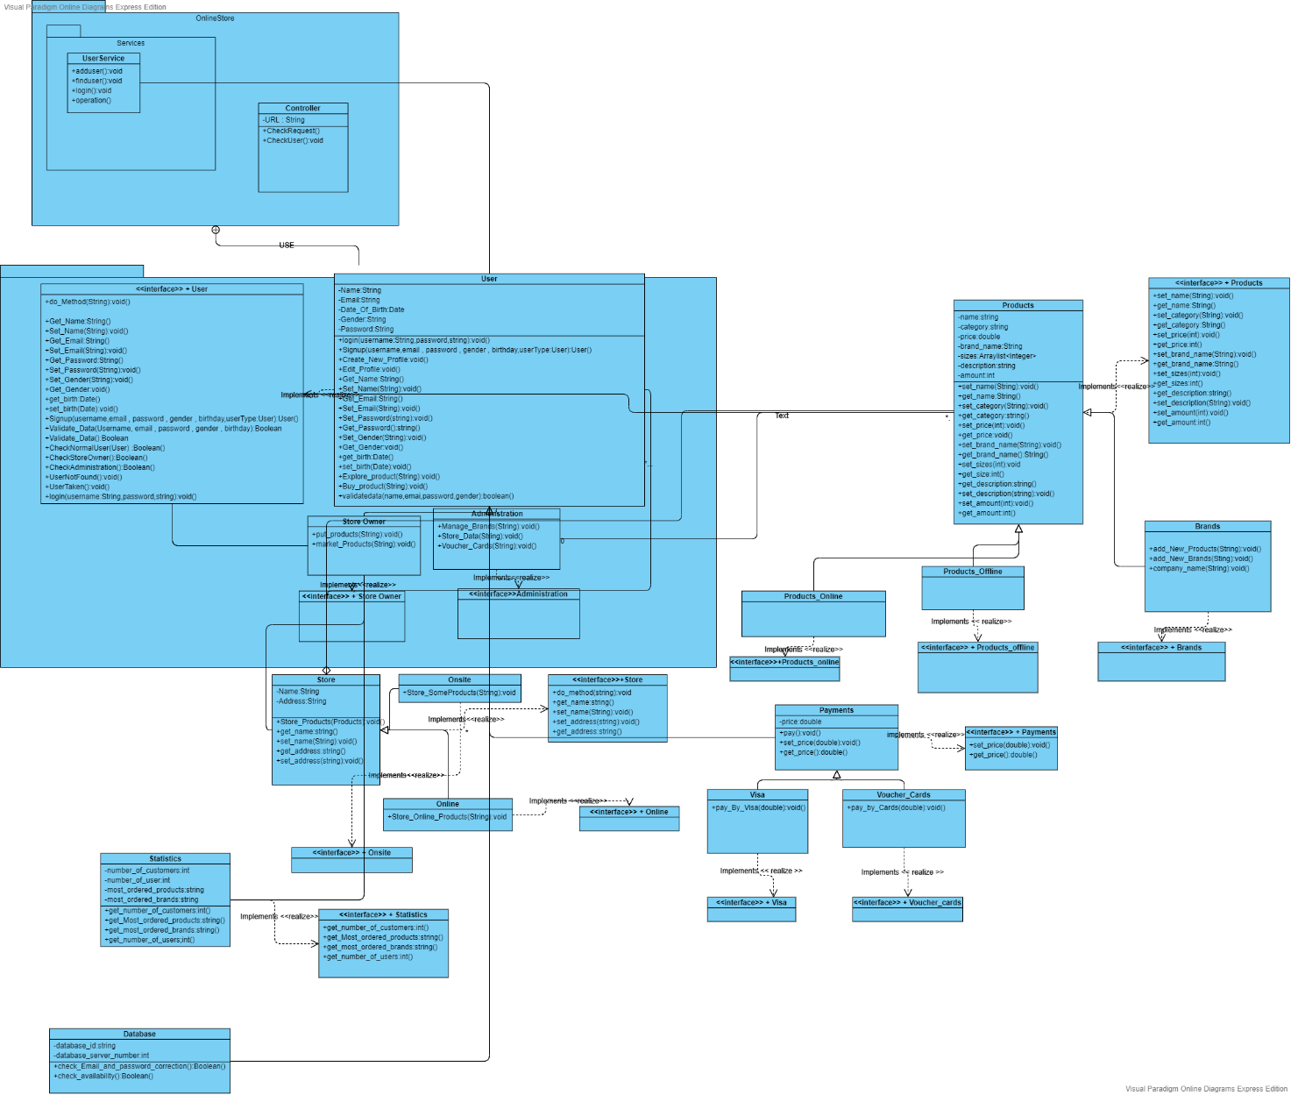

# Sequence diagram design

1.Buy products:

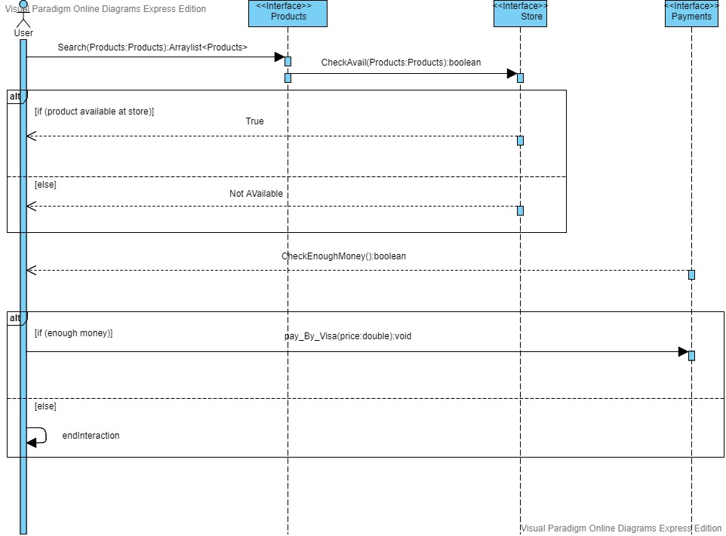

2.Add new brand

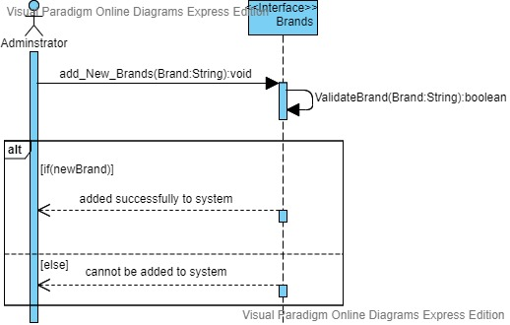

3.Add product to store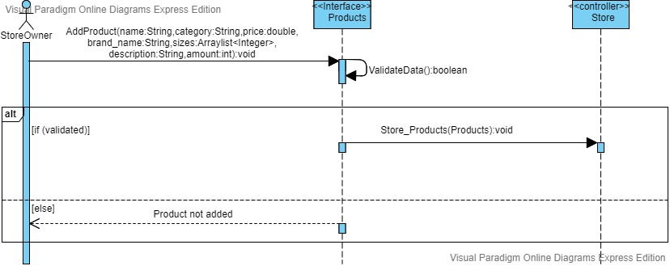

4.Sign up(Store Owner)

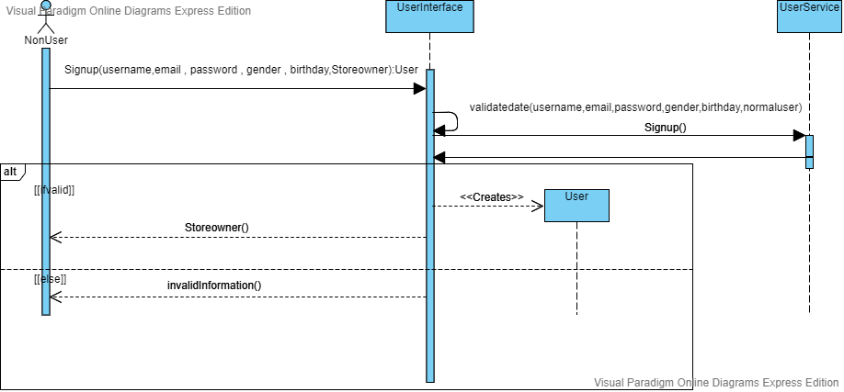

5.Explore Products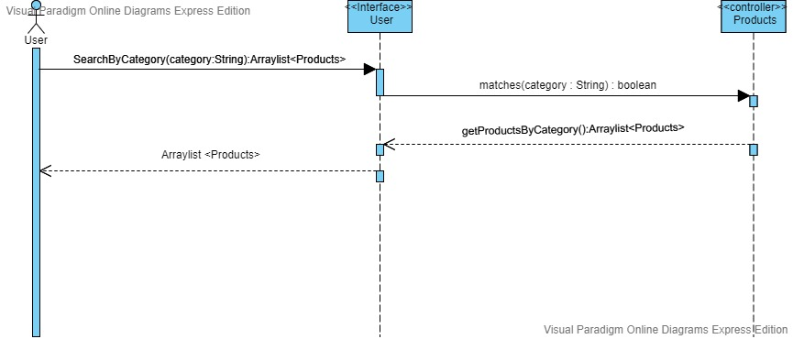

6.Log in (Store owner)

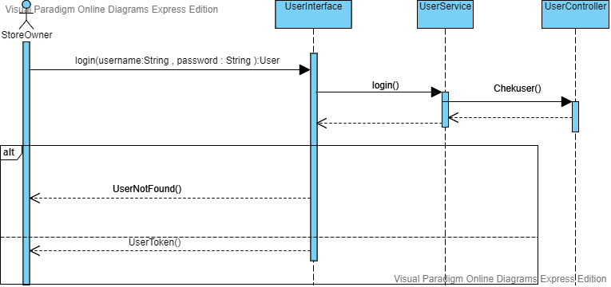

7.Log in (Normal User)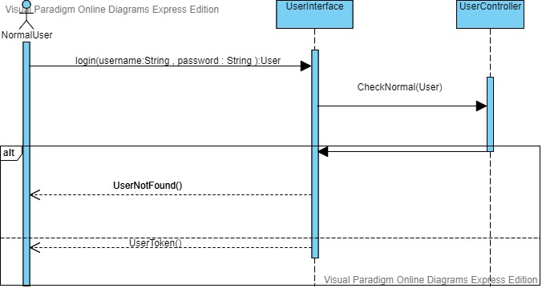

8. Log in (Administrator)

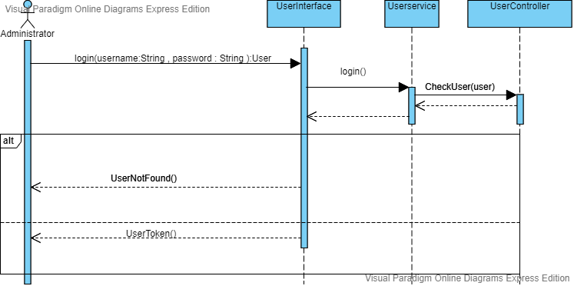

9.Sign up(Administrator)

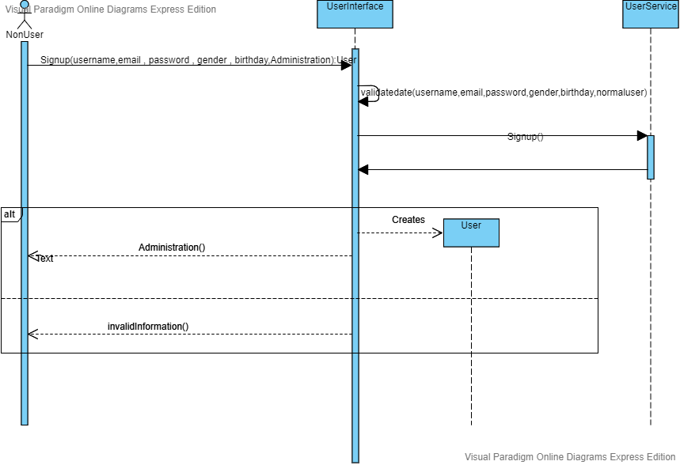

10.Sign up(Normal User)

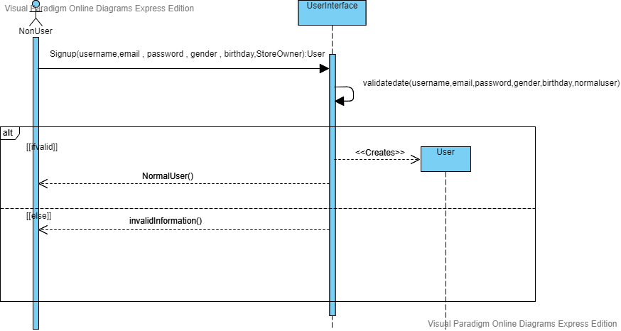

# Github repository link

* <https://github.com/alaafar256/SWE2_Project>